Seed Song Center REGISTRATION FORM For Fall Farm Camp Programs at Seed Song Farm
We have rolling admission until programs are full, which often happens quickly. Register early!
Part A: Child and Parent/Guardian Information
Please fill out a separate form for each child attending (skip all duplicate information)
Name of child (l,f):___________________________________Age:______ Gender:______
Name of contact parent/guardian (l,f):___________________________________________
Phone: mobile:__________________ home: ___ work:______________
Email: ___________________________________________________________________
Mailing address:___________________________________________________________
How did you hear about our summer program? ___________________________________
Does your child have any allergies? Please list them. ______________________________
“I permit Seed Song Center to take photos, videos, and sound clips of my child(ren) and my child(ren)'s projects at camp, and to use them at their discretion.”
(sign):____________________ (print name:) _____________________date: ____
Name of other parent/guardian if applicable: ____________________________________
Phone: mobile:________________ home: work:__________________
Email: ___________________________________________________________________
Address: _________________________________________________________________
Name of Other that may pick up child: _________________________________________
Phone: mobile:________________ home: work:__________________
Emergency Contact: name:________________________ phone(s):__________________
Please provide a paper copy of the child's immunization history when submitting your application, or bring prior to the child's ﬁrst day of camp.
Subpart 7-2 of the New York State Sanitary Code requires camps to maintain immunization records for all campers which includes dates for all immunizations against diphtheria, haemophilus inﬂuenza type b, hepatitis b, measles, mumps, rubella, poliomyelitis, tetanus and varicella (chickenpox). The record must be kept on ﬁle for every camper and updated annually.
Please also provide other medical/dietary/behavioral information you’d like us to know about your child, including attaching a copy of any applicable treatment plans or IEP:For NYS laws regarding summer camps, see link at www.seedsongfarm.org/about-camp.html
Part B: Attendance and Payment Information for Fall Day Programs
Please indicate all dates & time blocks for which you are registering
Full Full Full Per YOUR
MONTH DATES TIME BLOCK Season Month Week Day PAYMENT
M T W Th F Any 3 hrs between 12-6pm 15% 10% 5% < - - Discounted
Sept 13 14 15 16 17 12pm-3pm 3pm-6pm $1,680 $513 $180 $38 _______
20 21 22 23 24 12pm-3pm 3pm-6pm -- $180 $38 _______
27 28 29 30 1 12pm-3pm 3pm-6pm -- $180 $38 _______

Oct 4 5 6 7 8 12pm-3pm 3pm-6pm $650 $180 $38 _______
11 12 13 14 15 12pm-3pm 3pm-6pm -- $144 $38 _______
18 19 20 21 22 12pm-3pm 3pm-6pm -- $180 $38 _______
25 26 27 28 29 12pm-3pm 3pm-6pm -- $180 $38 _______

Nov 1 2 3 4 5 12pm-3pm 3pm-6pm $616 $180 $38 _______
8 9 10 11 12 12pm-3pm 3pm-6pm -- $180 $38 _______
15 16 17 18 19 12pm-3pm 3pm-6pm -- $180 $38 _______
22 23 24 12pm-3pm 3pm-6pm -- $108 $38 _______

FALL DAY PROGRAM SUB-TOTAL: _______
Please Forward our camp information to friends that may be interested:
https://www.seedsongfarm.org/camp.html
An essential part of our mission is to make our healthy farm experiences available to ALL
Make a tax-deductible contribution to Low-Income & Immigrant Camper Fund (optional): _______
Make a tax-deductible contribution to Camp Program Expansion Fund (optional): ______
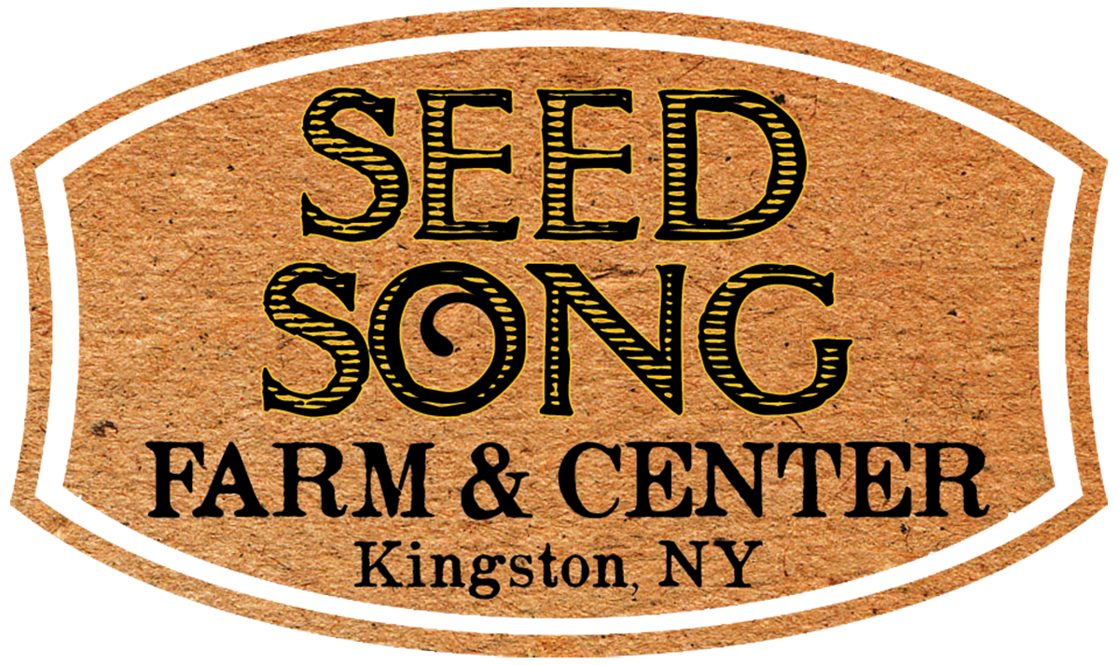
GRAND TOTAL : ______
CURRENT PAYMENT minimum 50%: ______
METHOD: [ ]Paypal [ ]Check #____ [ ]Cash [ ]Other ______
REMAINING BALANCE due (due date?): ______
Please proceed to the COVID-19 agreement on the next page.
Please e-mail or mail registration, medical, & covid forms to an address below.
Please Pay via Paypal link at https://www.seedsongfarm.org/register-for-camp.html or mail a check payable to 'Seed Song Center' to:
Seed Song Center, 160 Esopus Ave,Kingston, NY 12401
Parent COVID Agreement Form
To ensure that every child has as safe, fun, and meaningful an experience as possible
at Seed Song Center's Farm Camp, for the time being we require every parent to print and sign the following Covid Agreement Form and submit with registration.

Upon arrival to camp each day, the drop-off parent/guardian must initial a Temperature Log demonstrating that your child(ren)s temperature has been checked that morning (you can use our no-touch forehead bump thermometer if needed), that it is below 100.3 degrees F, and that the child has not exhibited any of the symptoms below:

Signs and symptoms of COVID-19: (compiled from WHO checklist)
~Shortness of breath ~Loss of taste or smell
~Chest tightness ~Dry cough
~Temp over 100.3 ~Aches and pains

Collective Agreement with Seed Song Center camp staff and families:
.
“By sending my child to Seed Song Center's camp, I pledge that my family's habits outside of camp will be transparent and safe on behalf of all camp families and staff. While my child(ren) attend(s) camp and for one week prior, my family and/or housemates will keep as safe a distance as practicable from any source of potential contagion.

If anyone in my home or my child(ren)'s home experiences an above-listed symptom of COVID-19, or has had contact with a known positive case in the last 14 days, we will not send our child(ren) to camp until we have gotten a negative test. I am aware that my actions at home could seriously impact essential workers and other camper families.

My child will bring a mask to camp each day, and will need to wear it whenever they are in an enclosed or shared space. I will ensure that the person that drops off and picks up my child wears a mask at these times and follows this agreement.

I understand that in order to serve families, Seed Song Center has committed resources to the camp program and staff even knowing the risk that camps may be shut down by New York State, or that one camp group may become infected and need to stay at home. I will share in this risk and am aware that camp fees can not be refunded in the case of a shut-down, as well as in the case of any child(ren) illness in which the child's space can not be filled from a waiting list.”

Name of Parent(s)/ Guardian(s) (please print): _______________________________

_______________________________

X _____________________________________ Date:______________

X _____________________________________ Date:______________
[signature(s)]

